The Tully App White Paper

Tully App is an artists' platform, built by and for creators, placing the power of production, promotion, and distribution into the palm of the hand of the people creating the astonishing musical experiences of this generation.

Mobile Technology Has Arrived

Mobile devices are the windows to the world in your pocket. They are the platform of choice for 18-49-year-olds. The listening and viewing of entertainment content on mobile devices continues to exceed traditional distribution models and is unlikely to change. Future generations will shortly come to see any device other than the mobile one in their hands as an anachronism.

With the increase in use comes an increase in power. The processing power of mobile devices is exceeding the requirements of most productivity applications that had hitherto been restricted to more powerful laptop and desktop computing devices.

In a recent article in the UK’s Guardian newspaper, it said, streaming music revenues overtook physical sales for the first time in 2017. The much-awaited tipping point in the music industry, which had relied on CDs sales since the 1980s, has arrived and with it comes exciting challenges and opportunities.

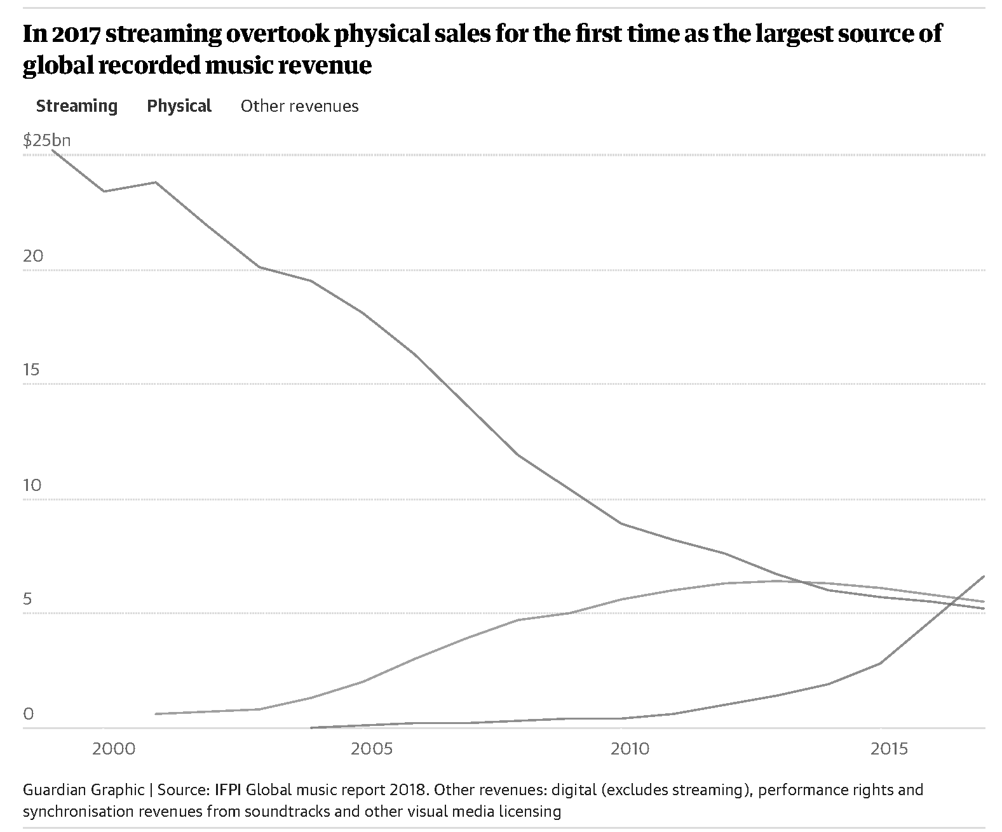

While streaming services are starting to pay a fairer share of their revenues to the music rights’ owners, YouTube, which is a significant distributor of music, still lags the rest of the industry. Whereas YouTube’s pays 67 cents per user annually, a service like Spotify is paying about $20 per user to the industry.

There is room to grow because after 15 years of music industry sales’ declines, being paid for music is beginning to catch up with traditional physical sales for artists. Recently, Congress passed the Music Modernization Act with the support of artists, streaming services, record labels and consumers alike. It will simplify how music is paid for and will help artists get paid more for their work.

There has never been a more opportune time for artists to start building a digital strategy for themselves from the spark of an idea to the returns of a stream.

A Mobile-Centric Set of Creativity Tools

At this significant point in the growth of a new music industry, built on the foundations of the old, and with the advent of new technologies, one industry entrepreneur, Dhruv Joshi, has developed a platform for today’s musical artists to enable their independence, their creativity, and their success well into a future dominated by digital devices and digital music services.

Joshi has been able to distill and capture the end-to-end experience of a modern artist, from the creation of a song, through its development, marketing, and ultimate distribution. Distilling the digital experiences of artists at both the creative level and the business level in order to create a single platform, Tully App, that gives the artists, their team, and collaborators everything they need to succeed. In the nascent digital music landscape Tully App is the unique achievement of Joshi and his engineers working with the artist community to find a future proof solution.

Through its partnership with emerging music superstar Joyner Lucas, Tully App has shown itself capable of meeting all the demands of today’s artists, giving them all the power and tools they need in the palm of their hand.

Together, Joshi and Lucas, are proving every day that Tully App is a creators’ platform built by creators who want to streamline the processes and behaviors of their own work and create new opportunities for their peers.

The Development of Tully App

Tully App’s initial development has focused on allowing the artist to bring together all the components of song creation, in collaboration with producers and engineers, and allowing an artist to manage it all on their handheld device. The creative workflow of writing, recording and creating a great song has been distilled into its essence.

If Lucas were not using Tully App every day in real-world environments, if he didn’t rely on it totally, and if it didn’t deliver value to him, then Joshi knew that it wasn’t going to work for anyone else. Joshi wanted Tully App to address the problems that Lucas was having in managing his own creative processes. Tully App was, first and foremost, built for Lucas as the first artist on the platform.

And as other artists and music pros and enthusiasts have flocked to Tully App, using it to collaborate and create, manage and elevate their work, it has become an indispensable tool of the trade. Every artist who engages with Tully App becomes a convert, an advocate for the platform and that is the greatest testament to its functionality.

Musical Collaboration in the Palm of Your Hand

Creativity is a collaborative process. An artist like Lucas gets inspired in many ways. Whether it is lyrics that he has created, beats he has heard, music that he needs, Joyner amasses layers upon layers of clips and files before he shapes his final work.

And like many artists, Lucas doesn’t know when, where, or how the inspiration will come. He only knows that when it comes he wants to be ready, he needs to be ready, to act.

With Tully App, Lucas can jot down lyrics, bring in sounds and music from a variety of sources, even acquire beats and tracks from other producers, wherever he is at any time.

Tully App allows all artists to experience untethered creativity and have the same opportunities as a major recording artist like Joyner.

A Single Creative Platform

The ability of Tully App to evolve as a single creative platform for a generation of artists who will never know anything other than being mobile is one of its most promising opportunities. Snapchat and Instagram have given free rein to creative talents to develop their own content and distribute it from a single mobile device, Tully App is a professional application that understands the needs of modern artists and is designed for the future of the music industry.

“I wanted Tully App to be something that didn’t require a sales pitch, that’s not what artists want to hear,” says Tully App founder Dhruv Joshi, “Artists want a transparent experience that naturally fits their creative workflow.”

Managing Digital Assets Should as Easy as Mobile Banking

As artists create and store more of their music using Tully App, they will need features to help them manage their most valuable asset – their digital masters.

Tully App provides secure, encrypted storage of digital music assets for artists and producers. Through the Tully App Digital Marketplace, producers are able to showcase and sell their digital assets to other artists as well as manage the workflow of song creation in a collaborative environment.

For artists, Tully App provides an opportunity for them to control and track their digital music files in a way that has not been possible before. As more and more of the industry converts into a totally digital distribution business, Tully App is uniquely positioned to enable greater management of artists’ digital assets.

Ultimately, Tully App is built as a total end-to-end solution that reflects the changing face of the music industry where digital distribution dominates and artists want more transparency and oversight of digital distribution.

Music for a Lifetime

Artists like Joyner Lucas are creating assets with lifelong value. They are also creating their own destiny through social media, self-promotion, live events, and direct relationships with their followers, all centered around mobile applications that are constantly in use, and always on. Tully App is designed to be the platform for these modern musical artist-impresarios.

Tully App delivers the power of a mobile musical platform for content creation and management in a way that directly reflects how Joyner Lucas, his team, his collaborators, and his audience work and play.

“If an artist like Lucas didn’t feel Tully is giving him what he needs, he won’t use it.” Says Joshi. “If Tully can make it easier for artists to create, it frees them up to focus on what’s important, the work. Tully App is totally an artist-centric product. We’re not creating artists, they are creating us.”

About Vertical Craft

Dhruv Joshi and co-founder Joyner Lucas founded Vertical Craft Inc in 2015 in San Francisco. The company develops technology tools for creative talent in the music industry. It’s primary product, Tully App, is an artists' platform, built by and for creators, placing the power of production, promotion, and distribution into the palm of the hand of the people creating the astonishing musical experiences of this generation.

Dhruv Joshi is a technology entrepreneur and manages recording artist Joyner Lucas. He has over a decade of experience in developing digital tools, services, and is an expert growth strategist in online marketing and distribution. Tully App was developed to help an artist and their team better leverage digital tools to streamline the collaboration and creation of music, while also enabling opportunities for digital growth through marketing and distribution.

Joyner Lucas is the chief evangelist, user, and artistic mind behind Tully App. Both Joshi and Lucas realized early on that without the complete support and devotion of artists Tully App would not succeed. They have developed a product that helps them grow in the music industry and are excited to see other artists benefit it from it and succeed on their own terms.

Contact Information:
<Press Contact Name>
<Title (optional)>
<Company>
press@tullyapp.com
<Phone (optional)>

